# **Banking Application**

**Modules:**

1. Check Balance
2. Deposit
3. Withdraw
4. Transfer
5. Exit

**Software Specifications:**

Client side technologies: HTML, CSS, Javascript

Programming Language: Java

Server side technologies: J2EE (Servlets and JSP)

Web Server: Tomcat

Database: Oracle

**Hardware Specifications**

Operating System: Windows family, Linux family

RAM: Min 500 MB

Processor: any processor

**Database tables:**

Note: We are not using separate login table temporarily.

**ACCOUNT**

ID – number

PASSWORD – varchar2

NUMBER – number

NAME - varchar2(100)

BALANCE – number(20,3)

**SQL QUERY: To create an account table.**

CREATE TABLE ACCOUNT(

ID NUMBER,

PASSWORD VARCHAR2(15),

NUM NUMBER,

NAME VARCHAR2(50),

BALANCE NUMBER(20,3));

**INSERT QUERY**

INSERT INTO ACCOUNT VALUES (101010,'123amr',112233, 'James Gosling', 5000);

INSERT INTO ACCOUNT VALUES (101011,'124amr',112234, 'Ken Smith', 5000);

COMMIT;

**Directory Structure of the application:**

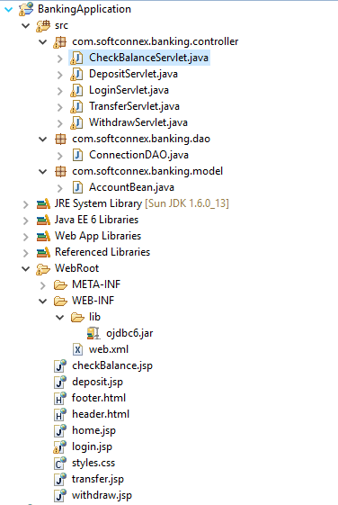

**Resource Files:**

header.html

footer.html

login.jsp -It’s for login purpose

home.jsp

checkBalance.jsp

deposit.jsp

withdraw.jsp

transfer.jsp

**Controllers:**

LoginServlet.java

CheckBalanceServlet.java

DepositServlet.java

WithdrawServet.java

TransferServlet.java

**DAO:**

ConnectionDAO.java

**Model:**

AccountBean.java

**Screens:**

**Login Screen:**

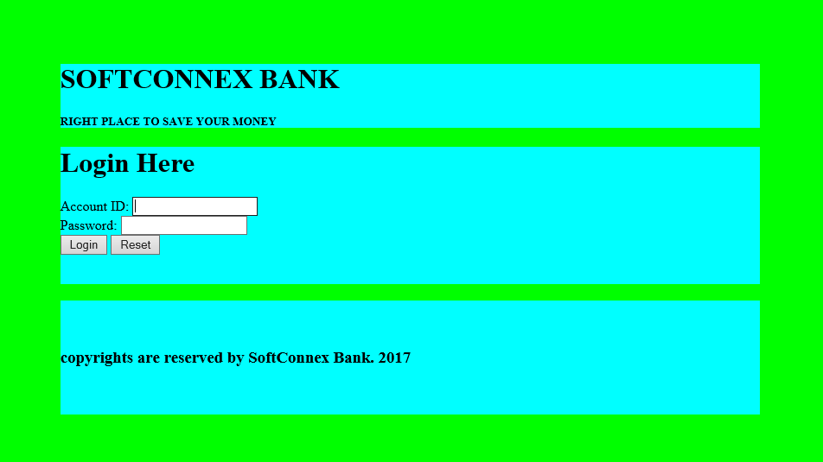

**Login Failure:**

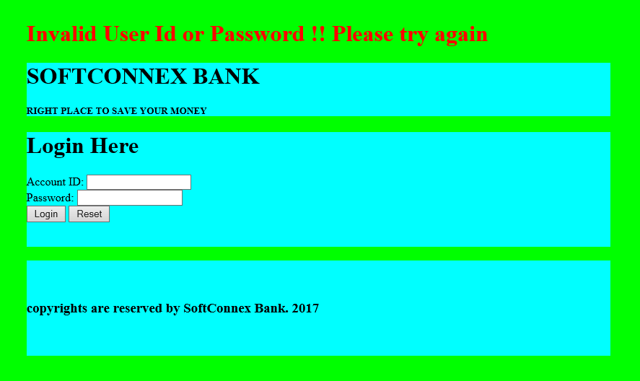

**Home Screen (Login success)**

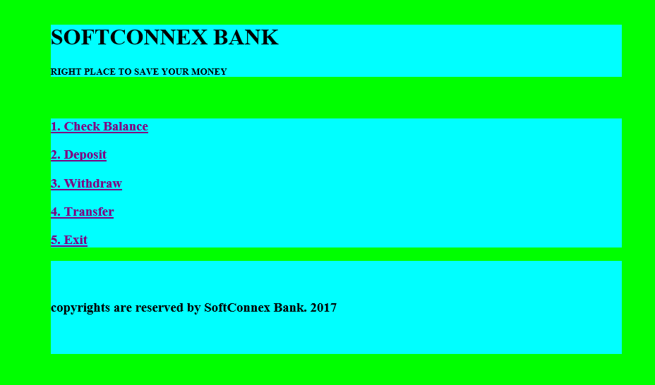

**Check Balance screen:**

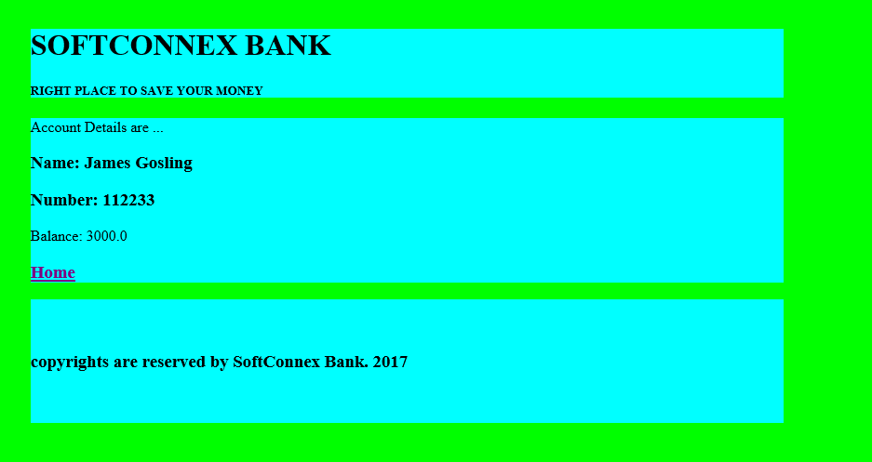

**Deposit screen:**

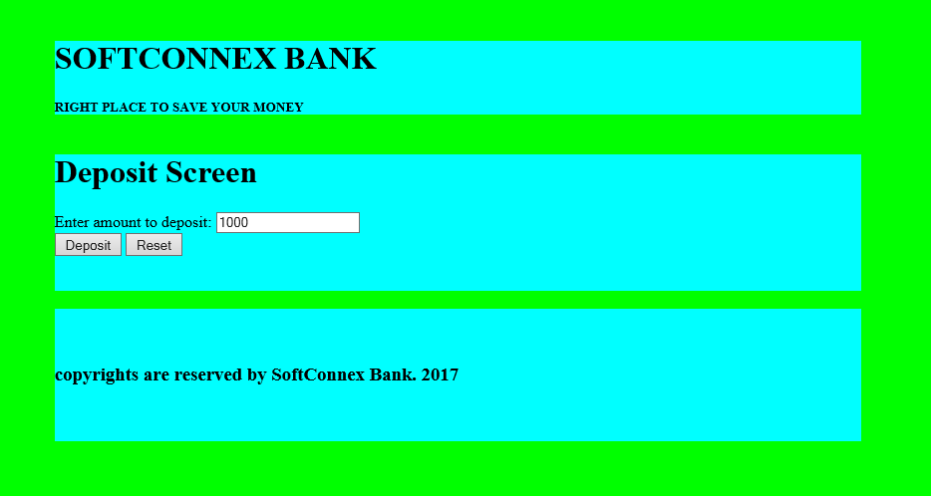

**Home screen (Deposit is done)**

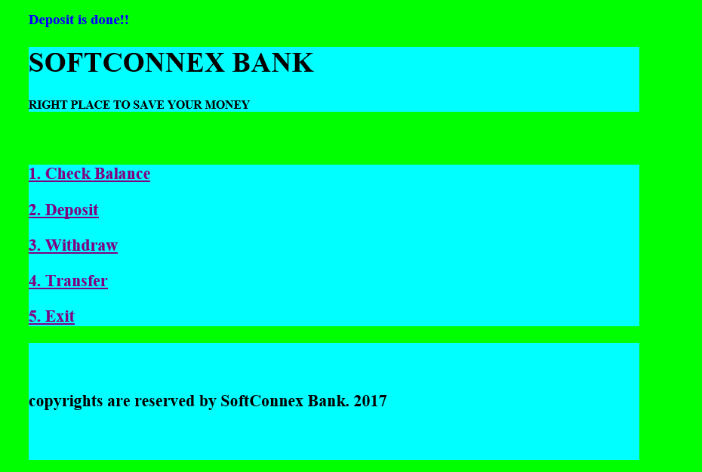

**Withdraw screen:**



**Home screen (Withdrawn is done)**



**Transfer screen:**

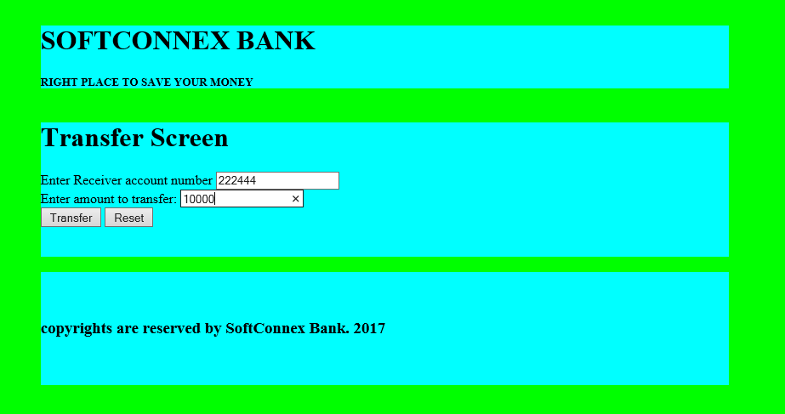**Home Screen (Transfer is done)**

